**Project Design Phase-II**

**Data Flow Diagram & User Stories**

|  |  |
| --- | --- |
| Date | 18 October 2022 |
| Team ID | PNT2022TMID32832 |
| Project Name | Project - Project - Detecting Parkinson’s  Disease using Machine Learning. |
| Maximum Marks | 4 Marks |

**Data Flow Diagrams:**

A Data Flow Diagram (DFD) is a traditional visual representation of the information flows within a system. A neat and clear DFD can depict the right amount of the system requirement graphically. It shows how data enters and leaves the system, what changes the information, and where data is stored.

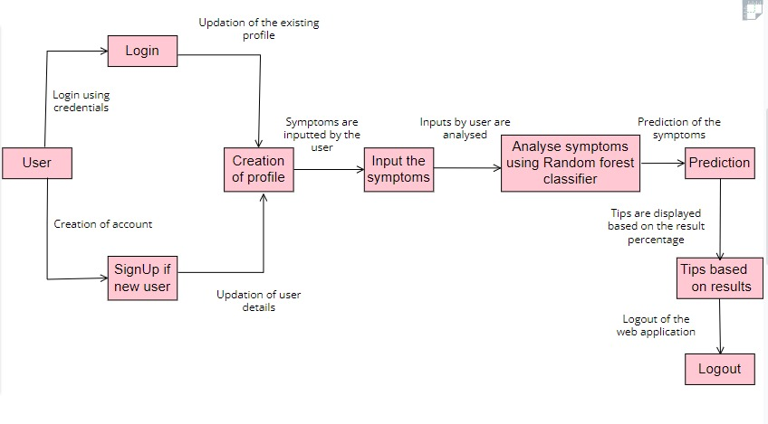

**User Stories**

Use the below template to list all the user stories for the product.

|  |  |  |  |  |  |  |
| --- | --- | --- | --- | --- | --- | --- |
| **User Type** | **Functional Requirement (Epic)** | **User Story Number** | **User Story / Task** | **Acceptance criteria** | **Priority** | **Release** |
| Customer (Web  user) | Home Page | USN-1 | Description about the Parkinson's disease. | I can get an idea about the disease. | Low | Sprint-3 |
|  |  | USN-2 | Details about the symptoms of the user is required. . |  | Low | Sprint-3 |
|  | Registration | USN-3 | As a user, I can register to the web  application by entering my username, email, phone number, and password, and confirming my password. | I can access my  account in a secured way . | Moderate | Sprint-3 |
|  |  | USN-4 | As a user, I will receive a  confirmation mail once I have signed up. | I will receive a  confirmation OTP upon registration for verification. | High | Sprint-3 |
|  | Login | USN-5 | As a user, I can log in to the web  application by entering my email id & password. | I can log in  Successfully as I am authorised. | High | Sprint-2 |
|  | Main  Page(Test vitals) | USN-6 | As a user, I submit the symptoms and the medical history required for the prediction. | I can access the  the web application and can submit the inputs required. | Moderate | Sprint-4 |
|  | Results | USN-7 | Results will be displayed along with  their accuracy. | I get my results  accurately. | High | Sprint-4 |
| Admin | Data  collection | USN-8 | Collect the required data for the  detection of Parkinson's disease |  | High | Sprint-1 |
|  | Data preprocessing | USN-9 | Clean and analyze the data to avoid noise and duplications | As a result I get the desired dataset to get trained. | High | Sprint-1 |
|  | Model  Building | USN-10 | Build the model using a Random  forest classifier and HOG to classify the images. | The trained model is successfully deployed. | High | Sprint-1 |
|  | Deploy the  model | USN-11 | Deployment of ML model using  IBM Watson.. | The web application is deployed  successfully. | High | Sprint-2 |
|  | Integrate the web app with the IBM model | USN-12 | Usage of flask for the integration purpose. | The web application is created successfully. | Moderate | Sprint-2 |